BENDIGO ALL BREEDS GOAT EXPO
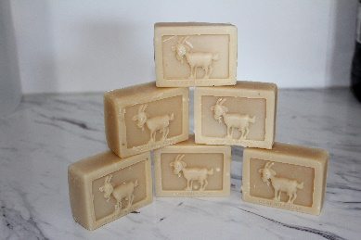
GOAT MILK SOAP COMPETITON
$5 PER ENTRY Please read rules and definitions before entering. Soaps will not be returned.
All soap to be Cold Process and the work of the entrant. Include 2 soaps per entry -one for display and one for testing. (Please label display soap).
Ingredient list to be with entry (not recipe).
Soaps will be judged on appearance, lather, feel.
CLASS 1 Plain - unscented
CLASS 2 Scented and coloured - may include essential and fragrance oils, clays, micas and other colourants
CLASS 3 Botanicals -must be of plant origin (may include oats, honey, flowers)
CLASS 4 Design soap - coloured or patterned. May be any design and may be scented or unscented must be at least two colours
CLASS | SOAP DESCRIPTION | FEE
DETAILS
Name……………………………………………………………………………………………………………………………………………..
Address…………………………………………………………………………………………………………………………………………..
…………………………………………………………………………………………………………………………………………………………
PHONE……………………………………………Email……………………………………………………….……………………………..
Entries close 13th March 2020. Soaps must be received by that date.
Soap and Forms to be sent to:
Belinda Cardinal – 765 Wiridgil Lane, Weerite, Vic, 3260
Direct Deposit NAB CAPROTEK 083-561 530126807
**PLEASE PUT ‘SOAP-SURNAME AS REFERENCE**
If unable to direct deposit please contact Belinda Cardinal 0418 573 458 for alternative payments

