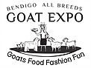
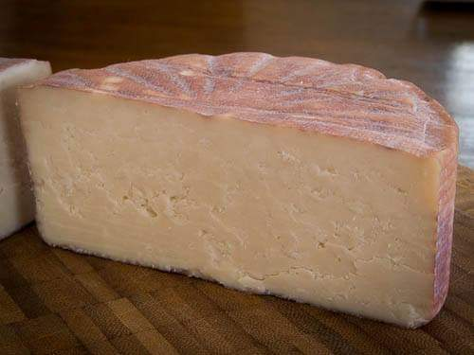
BENDIGO ALL BREEDS GOAT EXPO
GOAT MILK CHEESE COMPETITON
$5 PER ENTRY Please read rules and definitions before entering. Cheese will not be returned.
All Cheese to be made entirely from pasteurised goat milk and must be the work of the entrant.
ENTRANT MUST NOT BE A COMMERCIAL CHEESE MANUFACTURER

Include minimum 200 g unsliced piece per entry. Must be received cold.
CLASS 1 – FRESH CHEESE- may include chevre, ricotta,
CLASS 2 – SOFT CHEESE – may include camembert, Brie, washed rind
CLASS 3 – BLUE – may include Stilton, gorgonzola
CLASS 4 – SEMI HARD – may include gouda, swiss, cheddar etc
CLASS 5 - HARD – may include parmesan etc
CLASS | CHEESE DESCRIPTION | FEE
DETAILS
Name……………………………………………………………………………………………………………………………………………..
Address…………………………………………………………………………………………………………………………………………..
…………………………………………………………………………………………………………………………………………………………
PHONE……………………………………………Email……………………………………………………….……………………………..
Entries close 13th March. Cheese must be received by that date.
Cheese and Forms to be sent to:
Belinda Cardinal 765 Wiridgil Lane, Weerite, VIC, 3551
Direct Deposit NAB CAPROTEK 083-561 530126807
**PLEASE PUT ‘CHEESE-SURNAME AS REFERENCE**
If unable to direct deposit please contact Belinda Cardinal 0418 573 458 for alternative payments

